Module 11: Week 13: Required Assignment

1. Understanding NoSQL Databases (8 Marks)

a) Define NoSQL databases and describe their key features
NoSQL databases are non-relational databases or sometimes “Not-only SQL” databases if it supports SQL queries. Its key features are flexible schema and horizontal scalability.

b) Compare NoSQL vs SQL databases by creating a table with at least 4 parameters
Parameter | SQL | NoSQL
Schema | Fixed, predefined schema; all rows in a table share the same structure, type of the column is declared at table creation | Dynamic/flexible schema; structure can vary per record, each key can have different types
Scalability | Vertical | Vertical & horizontal
Data Storage | Tables with rows and columns; relational | Documents, key-value pairs, non-relational
Data Retrieval | Even a single-row fetch needs to go through relational overhead | Optimised for known access patterns with no JOINS
Consistency | ACID (Atomicity, Consistency, Isolation, Durability) | BASE (Basically Available, Soft state, Eventual consistency)

c) Mention 2 real-world use cases where NoSQL databases are more suitable than SQL databases
- Social media apps — user-generated data (posts, likes, connections) is high-volume and structurally variable; document stores allow data that's frequently accessed together (e.g. a post, its comments, its like count) to be stored in the same place and retrieved as one unit, avoiding the multiple joins a relational schema and allowing for fast scaling
- Navigation systems — location data needs fast, continuously updating "find nearest" or "within radius" queries (e.g., nearest petrol station, points along a route). MongoDB (NoSQL) supports this natively with GeoJSON storage and specialised geospatial indexes, whereas SQL databases need separate spatial extensions and are less suited to high-frequency location updates at scale due to the compute power required.

2. Working with MongoDB Collections and Documents (7 Marks)

a) Create a MongoDB database called LibraryDB.
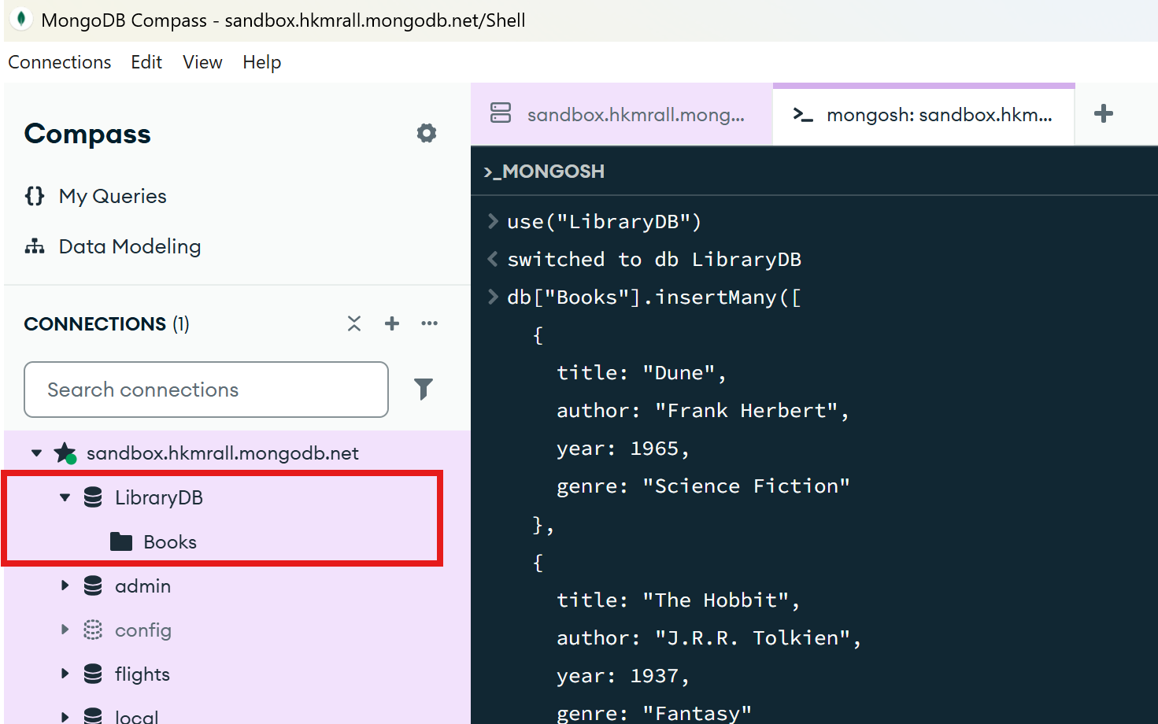

b) Create a collection Books and insert at least three documents with fields like title, author, year, and genre.
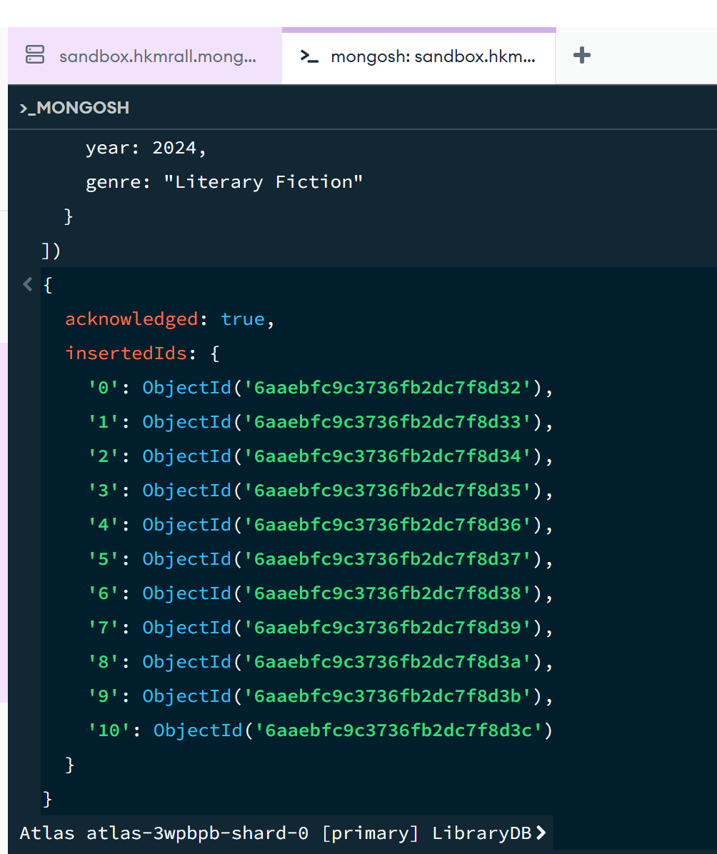

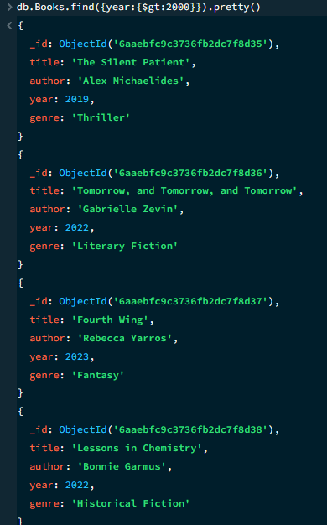
c) Use the find command to fetch all books where year is greater than 2000.
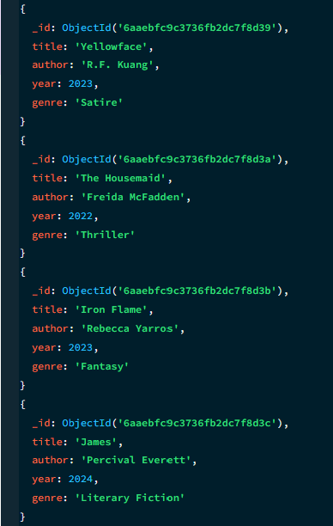

3. Updating and Deleting Documents in MongoDB (5 Marks)

a) Use the LibraryDB database and update the genre of the book titled "Book1" to "Classic Fiction".
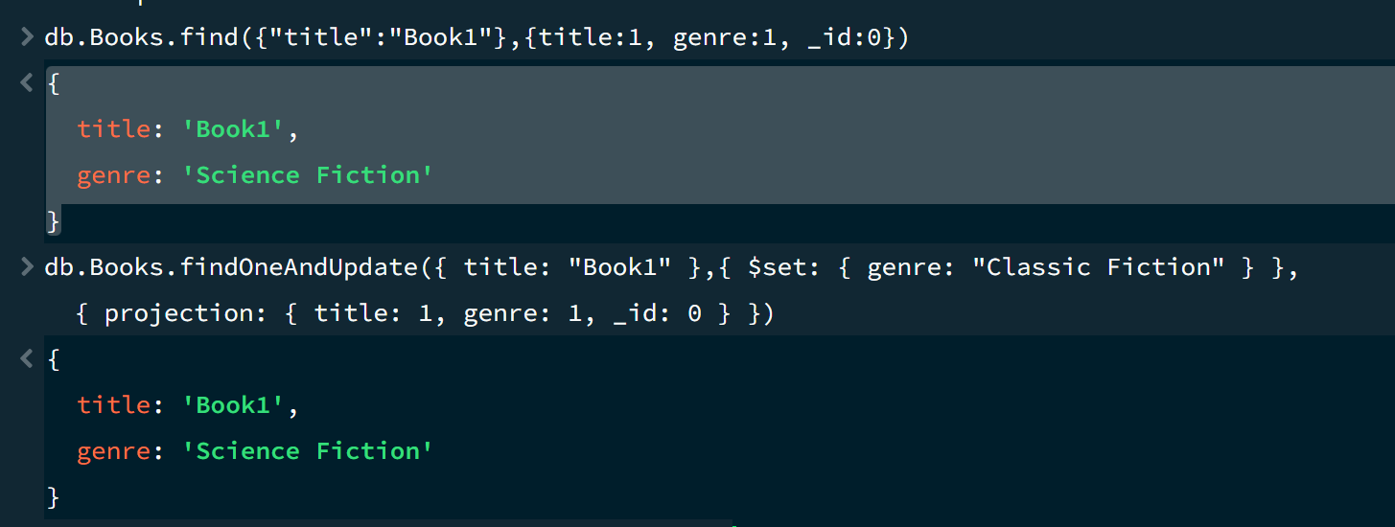

b) Delete any book in the collection where the year is less than 2000.
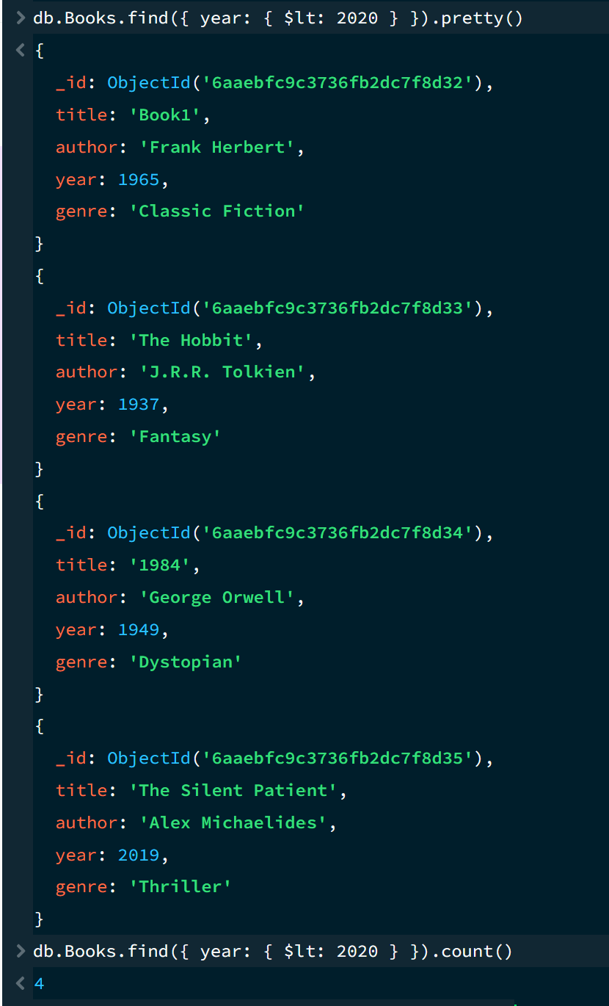
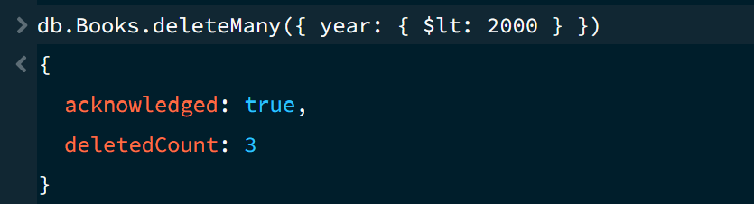

c) Use find() to verify the updates and deletions.
